# Know the 3 Main Groups of Chart Patterns

That’s a whole lot of chart patterns we just taught you right there. We’re pretty tired so it’s time for us to take off and leave it to you from here…

Just playin’! We ain’t leaving you till you’re ready!

In this section, we’ll discuss a bit more how to use these chart patterns to your advantage.

It’s not enough to just know how the tools work, we’ve got to learn how to use them. And with all these new weapons in your arsenal, we’d better get those profits fired up!

Let’s summarize the chart patterns we just learned and categorize them according to the signals they give.

## Reversal Chart Patterns

Reversal patterns are those chart formations that signal that the ongoing trend is about to change course.

If a reversal chart pattern forms during an uptrend, it hints that the trend will reverse and that the price will head down soon. Conversely, if a reversal chart pattern is seen during a downtrend, it suggests that the price will move up later on.

In this lesson, we covered six chart patterns that give reversal signals. Can you name all six of them?

1. Double Top
2. Double Bottom
3. Head and Shoulders
4. Inverse Head and Shoulders
5. Rising Wedge
6. Falling Wedge

If you got all six right, brownie points for you!

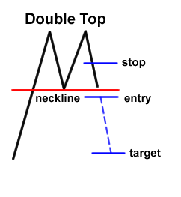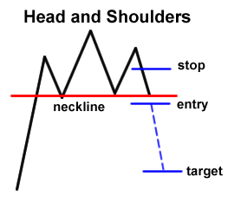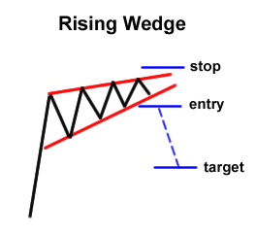

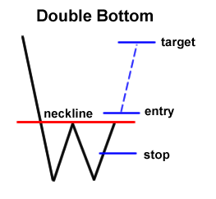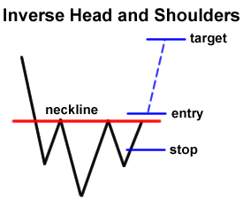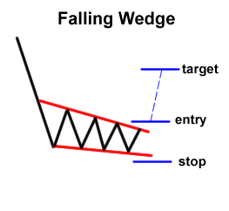

To trade these chart patterns, simply place an order beyond the neckline and in the direction of the new trend. Then go for a target that’s almost the same as the height of the formation.

For instance, if you see a double bottom, place a long order at the top of the formation’s neckline and go for a target that’s just as high as the distance from the bottoms to the neckline.

In the interest of proper risk management, don’t forget to place your stops! A reasonable stop loss can be set around the middle of the chart formation.

For example, you can measure the distance of the double bottoms from the neckline, divide that by two, and use that as the size of your stop.

## Continuation Chart Patterns

Continuation chart patterns are those chart formations that signal that the ongoing trend will resume.

Usually, these are also known as consolidation patterns because they show how buyers or sellers take a quick break before moving further in the same direction as the prior trend.

###### Advertisement

We’ve covered several continuation chart patterns, namely the wedges, rectangles, and pennants. Note that wedges can be considered either reversal or continuation patterns depending on the trend on which they form.

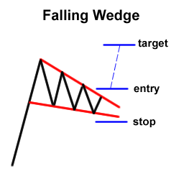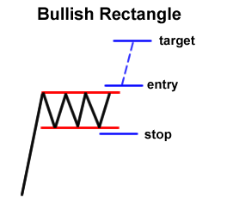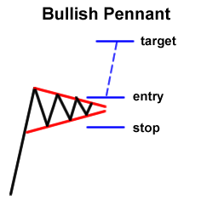

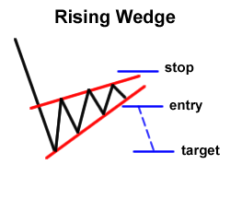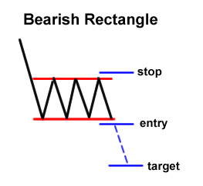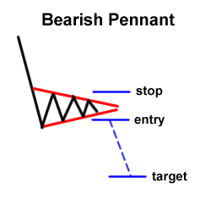

To trade these patterns, simply place an order above or below the formation (following the direction of the ongoing trend, of course). Then go for a target that’s at least the size of the chart pattern for wedges and rectangles.

For pennants, you can aim higher and target the height of the pennant’s mast.

For continuation patterns, stops are usually placed above or below the actual chart formation.

For example, when trading a bearish rectangle, place your stop a few pips above the top or resistance of the rectangle.

## Bilateral Chart Patterns

Bilateral chart patterns are a bit more tricky because these signal that the price can move either way.

Huh, what kind of a signal is that?!

This is where triangle formations fall in. Remember when we discussed that the price could break either to the topside or downside with triangles?

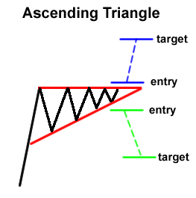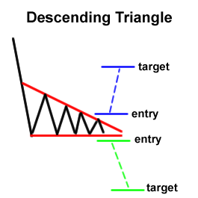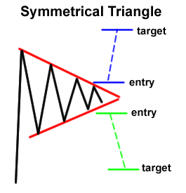

To play these chart patterns, you should consider both scenarios (upside or downside breakout) and place one order on top of the formation and another at the bottom of the formation.

If one order gets triggered, you can cancel the other one. Either way, you’d be part of the action.

Double the possibilities, double the fun!

The only problem is that you could catch a false break if you set your entry orders too close to the top or bottom of the formation.

So be careful and don’t forget to place your stops too!

# Forex Chart Patterns Cheat Sheet

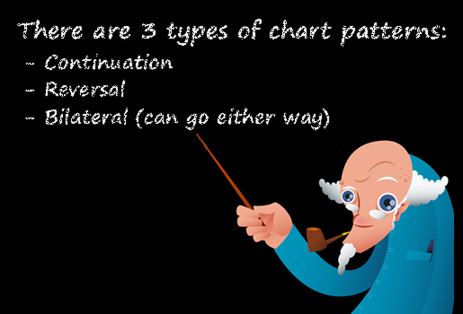

Like we promised, here’s a neat little cheat sheet to help you remember all those forex chart patterns and what they are signaling.

We’ve listed the basic forex chart patterns, when they are formed, what type of signal they give, and what the next likely price move may be. Check it out!

|  |  |  |  |
| --- | --- | --- | --- |
| **Chart Pattern** | **Forms During** | **Type of Signal** | **Next Move** |
| Double Top | Uptrend | Reversal | Down |
| Double Bottom | Downtrend | Reversal | Up |
| Head and Shoulders | Uptrend | Reversal | Down |
| Inverse Head and Shoulders | Downtrend | Reversal | Up |
| Rising Wedge | Downtrend | Continuation | Down |
| Rising Wedge | Uptrend | Reversal | Down |
| Falling Wedge | Uptrend | Continuation | Up |
| Falling Wedge | Downtrend | Reversal | Up |
| Bearish Rectangle | Downtrend | Continuation | Down |
| Bullish Rectangle | Uptrend | Continuation | Up |
| Bearish Pennant | Downtrend | Continuation | Down |
| Bullish Pennant | Uptrend | Continuation | Up |

You also might want to add this page to your bookmarks in case you need to double-check those chart patterns’ signals before you risk your hard-earned cash on a trade.  You never know when you’re gonna need to cheat, hah! Bookmark this thing yo!

And as you probably noticed, we didn’t include the triangle formations (symmetrical, ascending, and descending) in this cheat sheet. That’s because these chart patterns can form either in an uptrend or downtrend, and can signal either a continuation or reversal. Confusing I know, but that’s where practice and experience comes in!

Like we mentioned, it’s tough to tell where the forex market will breakout or reverse. So what’s important is that you prepare well and have your entry/exit orders ready so that you can be part of the action either way!

**How to Trade Triangle Chart Patterns**

**Symmetrical Triangle**

A **symmetrical triangle** is a chart formation where the slope of the price’s highs and the slope of the price’s lows converge together to a point where it looks like a triangle.

What’s happening during this formation is that the market is making lower highs and higher lows. This means that neither the buyers nor the sellers are pushing the price far enough to make a clear trend.

If this were a battle between the buyers and sellers, then this would be a draw.

This is also a type of consolidation.

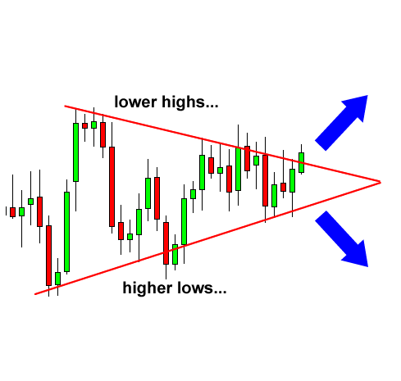

In the chart above, we can see that neither the buyers nor the sellers could push the price in their direction. When this happens we get lower highs and higher lows.

As these two slopes get closer to each other, it means that a breakout is getting near. We don’t know what direction the breakout will be, but we do know that the market will **most likely** break out. Eventually, one side of the market will give in.

So how can we take advantage of this?

Simple.

We can place entry orders above the slope of the lower highs and below the slope of the higher lows. Since we already know that the price is going to break out, we can just hitch a ride in whatever direction the market moves.

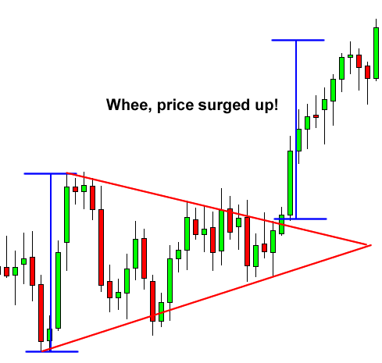

In this example, if we placed an entry order above the slope of the lower highs, we would’ve been taken along for a nice ride up.

If you had placed another entry order below the slope of the higher lows, then you would cancel it as soon as the first order was hit.

**Ascending Triangle**

This type of triangle chart pattern occurs when there is a resistance level and a slope of higher lows.

What happens during this time is that there is a certain level that the buyers cannot seem to exceed. However, they are gradually starting to push the price up as evident by the higher lows.

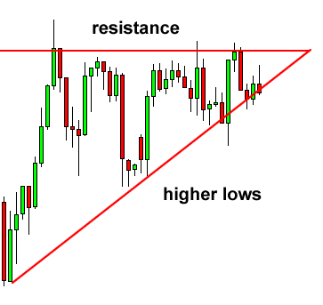

In the chart above, you can see that the buyers are starting to gain strength because they are making higher lows. They keep putting pressure on that resistance level and as a result, a breakout is bound to happen.

Advertisement

Now the question is, “Which direction will it go? Will the buyers be able to break that level or will the resistance be too strong?”

Many charting books will tell you that in most cases, the buyers will win this battle and the price will break out past the resistance.

However, it has been our experience that this is not always the case. Sometimes the resistance level is too strong, and there is simply not enough buying power to push it through.

Most of the time, the price will in fact go up. The point we are trying to make is that you should not be obsessed with which direction the price goes, but you should be ready for movement in EITHER direction.

In this case, we would set an entry order above the resistance line and below the slope of the higher lows.

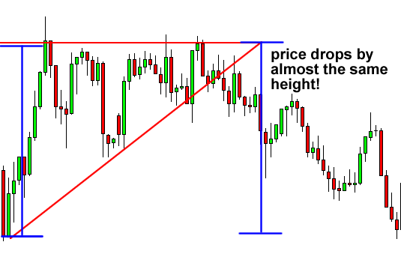

In this scenario, the buyers lost the battle and the price proceeded to dive! You can see that the drop was approximately the same distance as the height of the triangle formation.

If we set our short order below the bottom of the triangle, we could’ve caught some pips off that dive.

**Descending Triangle**

As you probably guessed, descending triangles are the exact opposite of ascending triangles (we knew you were smart!). In descending triangle chart patterns, there is a string of lower highs which forms the upper line. The lower line is a support level in which the price cannot seem to break.

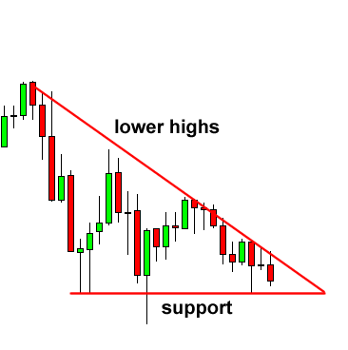

In the chart above, you can see that the price is gradually making lower highs which tell us that the sellers are starting to gain some ground against the buyers.

Now most of the time, and we do say MOST, the price will eventually break the support line and continue to fall.

However, in some cases the support line will be too strong, and the price will bounce off of it and make a strong move up.

The good news is that we don’t care where the price goes. We just know that it’s about to go somewhere. In this case, we would place entry orders above the upper line (the lower highs) and below the support line.

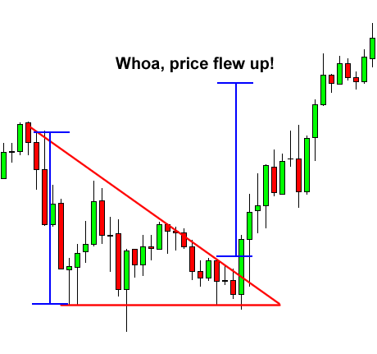

In this case, the price ended up breaking above the top of the triangle pattern. After the upside breakout, it proceeded to surge higher, by around the same vertical distance as the height of the triangle.

Placing an entry order above the top of the triangle and going for a target as high as the height of the formation would’ve yielded nice profits.

**How to Trade Bearish and Bullish Pennants**

**Bearish Pennants**

Similar to rectangles, pennants are continuation chart patterns formed after strong moves.

After a big upward or downward move, buyers or sellers usually pause to catch their breath before taking the pair further in the same direction. Because of this, the price usually consolidates and forms a tiny symmetrical triangle, which is called a pennant.

While the price is still consolidating, more buyers or sellers usually decide to jump in on the strong move, forcing the price to bust out of the pennant formation.

A **bearish pennant** is formed during a steep, almost vertical, downtrend. After that sharp drop in price, some sellers close their positions while other sellers decide to join the trend, making the price consolidate for a bit.

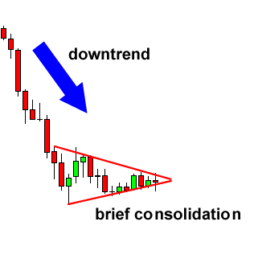

As soon as enough sellers jump in, the price breaks below the bottom of the pennant and continues to move down.

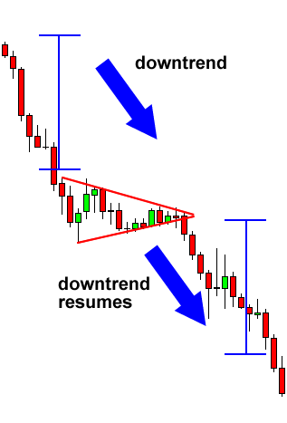

As you can see, the drop resumed after the price made a breakout to the bottom. To trade this chart pattern, we’d put a short order at the bottom of the pennant with a stop loss above the pennant. That way, we’d be out of the trade right away in case the breakdown was a fake out.

Unlike the other chart patterns wherein the size of the next move is approximately the height of the formation, pennants signal much stronger moves. Usually, the *height* of the earlier move (also known as the mast) is used to estimate the size of the breakout move.

**Bullish Pennant**

**Bullish pennants**, just like its name suggests, signals that bulls are about to go a-chargin’ again. This means that the sharp climb in price would resume after that brief period of consolidation, when bulls gather enough energy to take the price higher again.

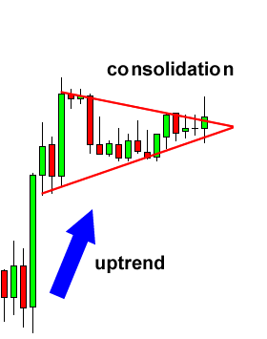

In this example, the price made a sharp vertical climb before taking a breather. I can hear the bulls stomping and revving up for another run!

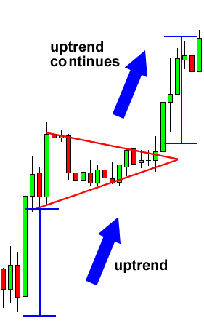

Just like we predicted, the price made another strong move upwards after the breakout. To play this, we’d place our long order above the pennant and our stop below the bottom of the pennant to avoid fake outs.

Like we discussed earlier, the size of the breakout move is around the height of the mast (or the size of the earlier move). You see, pennants may be small in size but they could signal huge price moves so don’t underestimate ’em!

**How to Trade Wedge Chart Patterns**

Wedges signal a pause in the current trend. When you encounter this formation, it signals that forex traders are still deciding where to take the pair next.

Wedges could serve as either continuation or reversal patterns.

**Rising Wedge**

A **rising wedge** is formed when price consolidates between upward sloping support and resistance lines.

Here, the slope of the support line is steeper than that of the resistance. This indicates that higher lows are being formed faster than higher highs. This leads to a wedge-like formation, which is exactly where the chart pattern gets its name from!

With prices consolidating, we know that a big splash is coming, so we can expect a breakout to either the top or bottom.

If the rising wedge forms after an uptrend, it’s usually a bearish reversal pattern.

On the other hand, if it forms during a downtrend, it could signal a continuation of the down move.

Either way, the important thing is that, when you spot this forex trading chart pattern, you’re ready with your entry orders!

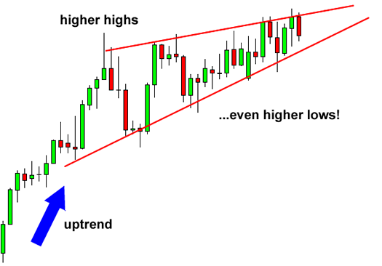

In this first example, a rising wedge formed at the end of an uptrend. Notice how price action is forming new highs, but at a much slower pace than when price makes higher lows.

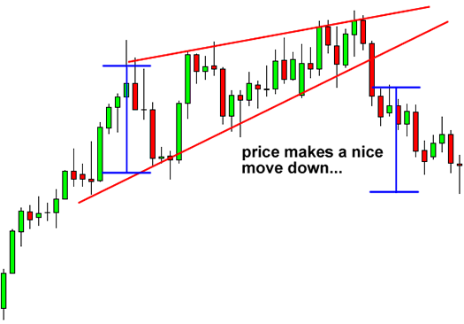

See how price broke down to the downside? That means there are more forex traders desperate to be short than be long!

They pushed the price down to break the trend line, indicating that a downtrend may be in the cards.

Just like in the other forex trading chart patterns we discussed earlier, the price movement after the breakout is approximately the same magnitude as the height of the formation.

Now let’s take a look at another example of a rising wedge formation. Only this time it acts as a bearish continuation signal.

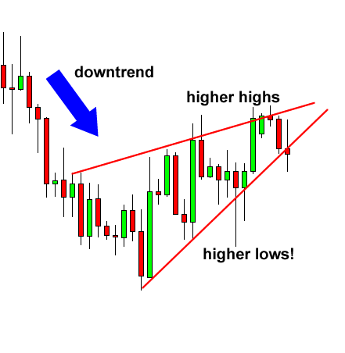

As you can see, the price came from a downtrend before consolidating and sketching higher highs and even higher lows.

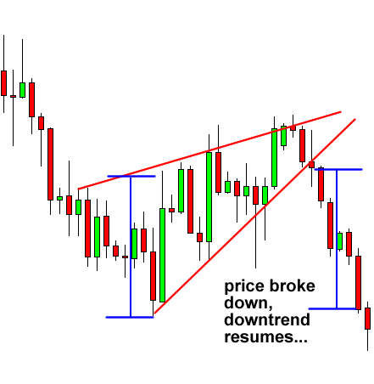

In this case, the price broke to the down side and the downtrend continued. That’s why it’s called a continuation signal yo!

Advertisement

See how the price made a nice move down that’s the same height as the wedge?

What did we learn so far these Japanese candlestick chart patterns?

A rising wedge formed after an uptrend usually leads to a reversal (downtrend) while a rising wedge formed during a downtrend typically results in a continuation (downtrend).

Simply put, a rising wedge leads to a downtrend, which means that it’s a bearish chart pattern!

**Falling Wedge**

Just like the rising wedge, the **falling wedge** can either be a reversal or continuation signal.

As a reversal signal, it is formed at a bottom of a downtrend, indicating that an uptrend would come next.

As a continuation signal, it is formed during an uptrend, implying that the upward price action would resume. Unlike the rising wedge, the falling wedge is a bullish chart pattern.

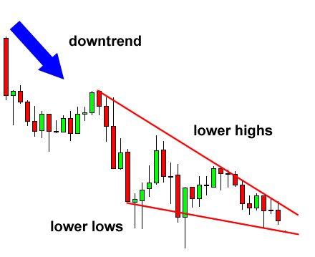

In this example, the falling wedge serves as a reversal signal. After a downtrend, the price made lower highs and lower lows.

Notice how the falling trend line connecting the highs is steeper than the trend line connecting the lows.

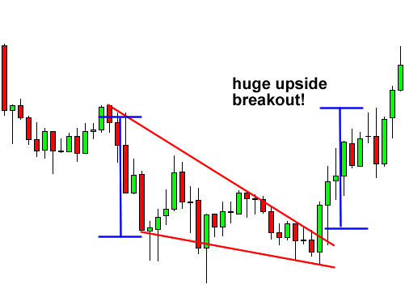

Upon breaking above the top of the wedge, the pair made a nice move upwards that’s approximately equal to the height of the formation. In this case, the price rally went a few more pips beyond that target!

Let’s take a look at an example where the falling wedge serves as a continuation signal. Like we mentioned earlier, when the falling wedge forms during an uptrend, it usually signals that the trend will resume later on.

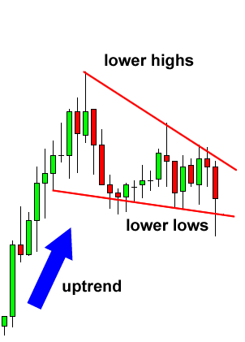

In this case, the price consolidated for a bit after a strong rally. This could mean that buyers simply paused to catch their breath and probably recruited more people to join the bull camp.

Hmm, it looks like the pair is revving up for a strong move. Which way would it go?

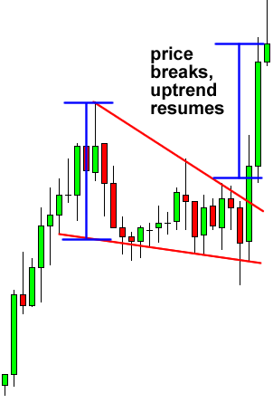

See how the price broke to the top side and went on to climb higher?

If we placed an entry order above that falling trend line connecting the pair’s highs, we would’ve been able to jump in on the strong uptrend and caught some pips! A good upside target would be the height of the wedge formation.

If you want to go for more pips, you can lock in some profits at the target by closing down a portion of your position, then letting the rest of your position ride.

**How to Trade the Head and Shoulders Pattern**

**Head and Shoulders**

A head and shoulders pattern is also a trend reversal formation.

It is formed by a peak (shoulder), followed by a higher peak (head), and then another lower peak (shoulder). A “neckline” is drawn by connecting the lowest points of the two troughs. The slope of this line can either be up or down. Typically, when the slope is down, it produces a more reliable signal.

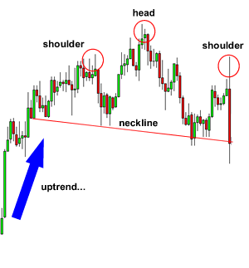

In this example, we can easily see the head and shoulders pattern.

The head is the second peak and is the highest point in the pattern. The two shoulders also form peaks but do not exceed the height of the head.

With this formation, we put an entry order below the neckline.

We can also calculate a target by measuring the high point of the head to the neckline. This distance is approximately how far the price will move after it breaks the neckline.

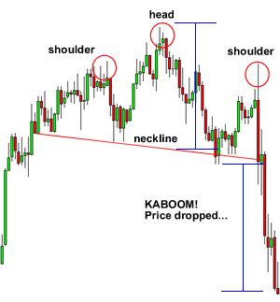

You can see that once the price goes below the neckline it makes a move that is at least the size of the distance between the head and the neckline.

We know you’re thinking to yourself, “the price kept moving even after it reached the target.”

Advertisement

And our response is, “**DON”T BE GREEDY!**”

**Inverse Head and Shoulders**

The name speaks for itself. It is basically a head and shoulders formation, except this time it’s upside down.

A valley is formed (shoulder), followed by an even lower valley (head), and then another higher valley (shoulder). These formations occur after extended downward movements.

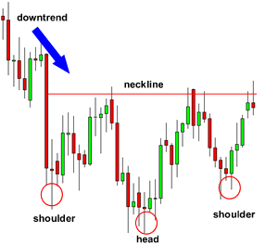

Here you can see that this is just like a head and shoulders pattern, but it’s flipped upside down. With this formation, we would place a long entry order above the neckline.

Our target is calculated just like the head and shoulders pattern. Measure the distance between the head and the neckline, and that is approximately the distance that the price will move after it breaks the neckline.

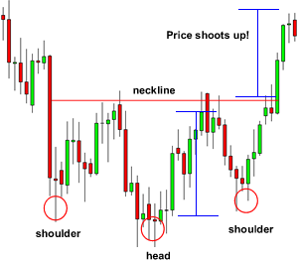

You can see that the price moved up nicely after it broke the neckline.

If your target is hit, then be happy with your profits. However, there are trade management techniques where you can lock in some of your profits and still keep your trade open in case the price continues to move your way.

You will learn about those later on in the course.

**How to Trade Double Tops and Double Bottoms**

**Double Top**

A double top is a reversal pattern that is formed after there is an extended move up. The “tops” are peaks which are formed when the price hits a certain level that can’t be broken.

After hitting this level, the price will bounce off it slightly, but then return back to test the level again. If the price bounces off of that level again, then you have a DOUBLE top!

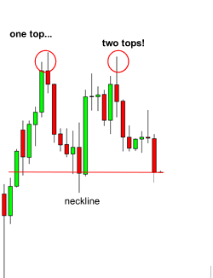

In the chart above you can see that two peaks or “tops” were formed after a strong move up.

Notice how the second top was not able to break the high of the first top. This is a strong sign that a reversal is going to occur because it is telling us that the buying pressure is just about finished.

With the double top, we would place our entry order below the neckline because we are anticipating a reversal of the uptrend.

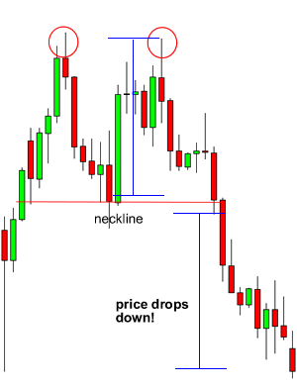

Wow! We must be psychic or something because we always seem to be right!

Looking at the chart you can see that the price breaks the neckline and makes a nice move down. Remember that double tops are a trend reversal formation so you’ll want to look for these after there is a strong uptrend.

You’ll also notice that the drop is approximately the same height as the double top formation. Keep that in mind because that’ll be useful in setting profit targets.

**Double Bottom**

The double bottom is also a trend reversal formation, but this time we are looking to go long instead of short. These formations occur after extended downtrends when two valleys or “bottoms” have been formed.

[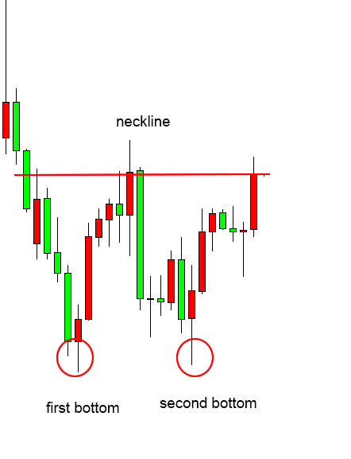](http://www.babypips.com/images/school/images/grade7/double-bottom-before.png)

You can see from the chart above that after the previous downtrend, the price formed two valleys because it wasn’t able to go below a certain level.

Notice how the second bottom wasn’t able to significantly break the first bottom. This is a sign that the selling pressure is about finished, and that a reversal is about to occur.

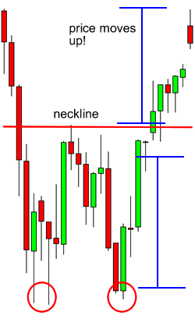

Will you look at that!

The price broke the neckline and made a nice move up.

See how the price jumped by almost the same height as that of the double bottom formation?

Remember, just like double tops, double bottoms are also trend reversal formations. You’ll want to look for these after a strong downtrend.

# How to use Pivot Points for Range Trading

The simplest way to use pivot point levels in your forex trading is to use them just like your regular support and resistance levels. Just like good ole support and resistance, price will test the levels repeatedly.

The more times a currency pair touches a pivot level then reverses, the stronger the level is. Actually, “pivoting” simply means reaching a support or resistance level and then reversing.

If you see that a pivot level is holding, this could give you some good trading opportunities.

If price is nearing the upper resistance level, you could sell the pair and place a stop just above the resistance.

If price was nearing a support level, you would buy and put your stop just below the level.

See? Just like your regular support and resistance! Nothing hard about that!

Let’s take a look at an example so you can visualize this. Here’s a 15-minute chart of GBP/USD.

[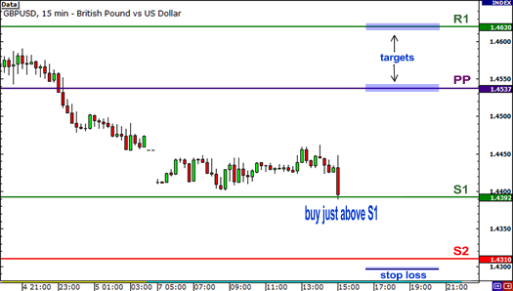](http://www.babypips.com/images/school/images/grade8/pivot-points-range-start.png)

In the chart above, you see that price is testing the S1 support level. If you think it will hold, what you can do is buy at market and then put a stop loss order past the next support level.

If you’re conservative, you can set a wide stop just below S2. If price reaches past S2, chances are it won’t be coming back up, as both S1 and S2 could become resistance levels.

If you’re a little more aggressive and confident that support at S1 would hold, you can set your stop just below S1.

###### Advertisement

As for your take profit points, you could target PP or R1, which could also provide some sort of resistance. Let’s see what happened if you bought at market.

[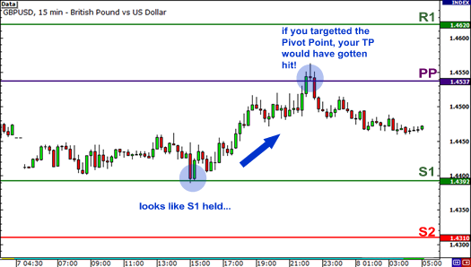](http://www.babypips.com/images/school/images/grade8/pivot-points-range-end.png)

And bam! Looks like S1 held as support! What’s more, if you had targeted PP as your take profit point, you would have hit your PT! Woohoo! Ice cream and pizza for you!

Of course, it ain’t always that simple. You shouldn’t rely only on the pivot point levels. You should note whether pivot point levels line up with former support and resistance levels.

You can also incorporate [candlestick](http://www.babypips.com/school/elementary/japanese-candle-sticks/what-is-a-japanese-candlestick.html) analysis and other types of indicators to help give you more confirmation.

For example, if you see that a [doji](http://www.babypips.com/school/elementary/japanese-candle-sticks/basic-candlestick-patterns.html) has formed over S1, or that the stochastic is indicating oversold conditions, then the odds are higher that S1 will hold as support.

Also, most of the time, trading normally takes place between the first support and resistance levels. Occasionally, price will test the second levels and every once in a while, the third levels will be tested.

Lastly, you should also fully understand that sometimes, price will just break through all the levels like how [Rafael Nadal](http://en.wikipedia.org/wiki/Rafael_Nadal) breezes through the competition at the French Open.

What will you do when that happens? Continue to hold onto your trade and be a sucker and watch your account dwindle away? Or will you take advantage and get back some pips?